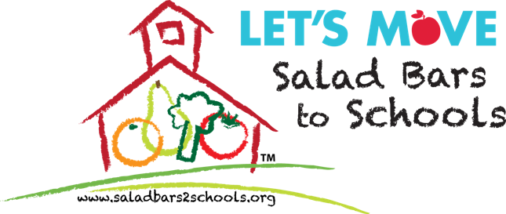

NEWS RELEASE
October 6, 2016

Contact: Dr. Lorelei DiSogra

ldisogra@unitedfresh.org
202-303-3403

Two Students from Flint, MI, Help the President & First Lady Michelle Obama Harvest the White House Garden
Students Represent Let’s Move Salad Bars to Schools

WASHINGTON, D.C. (October 6, 2016) – Today, two students representing Let’s Move Salad Bars to Schools from Freeman Elementary School, Flint Community School District, Flint, MI, helped First Lady Michelle Obama harvest the White House Kitchen Garden. Xavier Purches, a 5th grade student, and A’Layia Howard, a 4th grade student, also helped White House Chefs prepare a meal with fruits and vegetables from the White House garden. Two of only 22 kids in the entire country invited to participate, Xavier and A’Layia were joined by students representing other Let’s Move! initiatives.

To add to the excitement of the day, President Barack Obama visited the White House garden to meet the students and joined First Lady Michelle Obama in a group photo. Xavier and A’layia were thrilled to meet the President and First Lady. A’layia worked side-by-side in the garden with the First Lady, and enjoyed preparing a grilled flat bread with basil pesto and garden fresh veggies with the First Lady and Sam Kass. As an added bonus, she got to eat the flatbread with the First Lady too! Xavier spent the day harvesting, preparing and enjoying the fruits of their labor with Al Roker from NBC.

To improve child nutrition and mitigate exposure to lead, 19 schools in Flint, MI, including Freeman Elementary School, received salad bars this year from Let’s Move Salad Bars to Schools in partnership with Blue Cross Blue Shield of Michigan. The United Fresh Start Foundation, a founding partner of Let’s Move Salad Bars to Schools, lead efforts to coordinate the donation of salad bars to all schools in the Flint Community School District and four other school districts in Flint.

Let’s Move Salad Bars to Schools, Blue Cross Blue Shield of Michigan, the United Fresh Start Foundation and North Bay Produce, are committed to supporting additional salad bars to benefit the children of Flint.

“Good nutrition can play a pivotal role in helping children limit the effects of exposure to lead. Increasing consumption of fresh fruits and vegetables, especially fruits and vegetables rich in calcium, vitamin C and iron, such as dark green leafy vegetables, citrus fruits, strawberries, tomatoes, broccoli, kiwi, and melons, is critically important. The salad bars donated to Flint schools increase children’s access to a wide variety of fresh fruits and vegetables every day at school lunch,” said Dr. Lorelei DiSogra, United Fresh’s Vice President of Nutrition and Health.

Xavier and A’Layia were selected by Principal Anita Steward, Freeman Elementary School, and Superintendent Bilal Tawwab, Flint Community School District, to represent Let’s Move Salad Bars to Schools at the White House event because they love their school salad bars. The students are leaders and role models in their school, have excellent grades, and enjoy the variety of fresh fruits and vegetables offered at their salad bars every day. The students, chaperoned by 5th grade teacher Mrs. Kathy Savoie, were very excited to fly to Washington, D.C. (their first time in an airplane), visit the White House, meet the President and Mrs. Obama, visit the Lincoln Memorial and The Capitol, and share their story of how salad bars are helping children in Flint.

Let’s Move Salad Bars to Schools supports First Lady Michelle Obama’s Let’s Move! initiative to improve child nutrition and reduce obesity. To date, Let’s Move Salad Bars to Schools has donated salad bars to 4,800 schools nationwide; 300 in Michigan alone. The United Fresh Start Foundation, Chef Ann Foundation, Whole Foods Market, and National Fruit and Vegetable Alliance are founding partners of Let’s Move Salad Bars to Schools.

Schools interested in requesting salad bars can visit www.saladbars2schools.org.

###

Let’s Move Salad Bars to Schools
Let's Move Salad Bars to Schools is a public health campaign to increase salad bars in schools across the country so that every child has the choice of healthy fruits and vegetables every day at school. Let’s Move Salad Bars to Schools supports First Lady Michelle Obama's Let's Move! initiative to end childhood obesity in a generation. Founding partners are: The United Fresh Start Foundation, National Fruit and Vegetable Alliance, Chef Ann Foundation, and Whole Foods Market. More information can be found online at www.saladbars2schools.org.

About The United Fresh Start Foundation
The United Fresh Start Foundation is focused exclusively on increasing children’s access to fresh fruits and vegetables, and inspiring the next generation to “choose fresh” whenever and wherever they are eating their next snack or meal. Working with the produce industry, local nonprofits, healthcare organizations, allied businesses, and others, the United Fresh Start Foundation is committed to helping today’s youth achieve the public health goal of making half their plate fruits and vegetables in order to live longer, healthier lives. The Foundation is also a founding partner of the national Let’s Move Salad Bars to Schools initiative. Join our movement to ensure kids everywhere are “Growing Up Fresh!” More info at: www.unitedfreshstart.org

Pictures

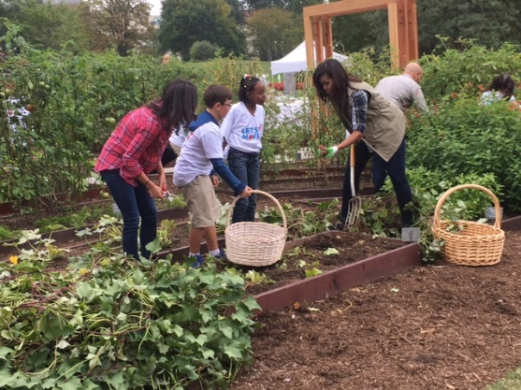
Caption: A’Layia Howard with First Lady Michelle Obama in the White House Kitchen Garden.

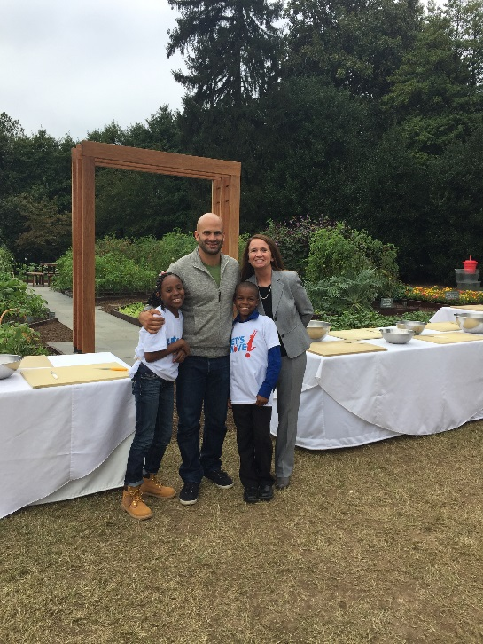

Caption: Sam Kass, former Executive Director of Let’s Move! standing in front of the new arbor in the White House Kitchen Garden with A’Layia Howard and Xavier Purches, students from the Flint Community School District (Flint, MI), and teacher, Mrs. Kathy Savoie.

Caption: Students from across the country who are benefitting from the Let’s Move! initiative, including two students from Flint, are joined in the White House Kitchen Garden with President Barack Obama, First Lady Michelle Obama and Let’s Move! partners and celebrities.

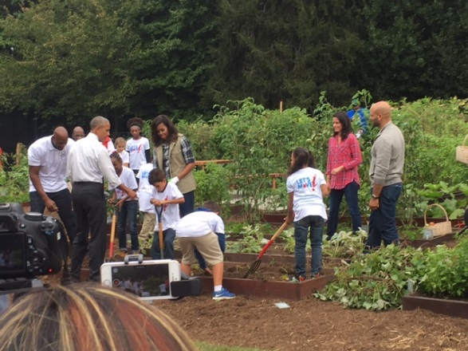

Caption: President Obama joins the First Lady and students in the White House Kitchen Garden.

