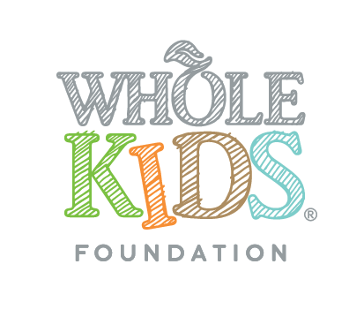
N E W S R E L E A S E

FOR IMMEDIATE RELEASE

Media Contact:
Ann Marie Ricard, Curator PR for Whole Kids Foundation

annmarie.ricard@curatorpr.com / 206.683.0552

Whole Kids Foundation Celebrates its Fifth Anniversary

4 million children reached through programs including salad bars in schools, school gardens and teacher education

AUSTIN, Texas (September 12, 2016) – This month marks an important milestone for Whole Kids Foundation as it celebrates five years as an organization dedicated to supporting schools and inspiring families to improve children’s nutrition and wellness.

Since inception in 2011, Whole Kids Foundation invested $15 million in programs that have served more than four million children in the United States, Canada and the U.K. In five years, the foundation has provided funds for over 3,600 school gardens and implemented 4,400 salad bars in schools. Additionally, Whole Kids Foundation has reached 11,000 teachers with its healthy teacher education program and developed elementary curriculum for school gardens, in partnership with American Heart Association, available at no cost to all schools.

“After five years as an organization, we can clearly see the shift towards a culture of health and nutrition for children and are proud to be part of that momentum,” said Nona Evans, president and executive director for Whole Kids Foundation. “We are energized by the impact of our work, and remain focused on innovative solutions that will help us reach even more children and improve access to nutrition and healthy food.”

A spirit of innovation shines through in several new initiatives launched by the organization this year. For example, Whole Kids Foundation partnered with Farm to Cafeteria Canada to introduce a grant program that will deliver $500,000 in funds and training support to 50 schools in Ontario and British Columbia. Additionally, the organization piloted the School Food Support Initiative in partnership with the Chef Ann Foundation and Lifetime Fitness Foundation to help five U.S. school districts get comprehensive support necessary to overhaul their school meal programs. And finally, in partnership with Whole Foods Market®, Whole Kids Foundation created an Educational Farm in Roswell, Georgia to provide experiential learning about food to local schools and community residents. The farm is in the process of becoming USDA Certified Organic, and runs a successful Community Supported Agriculture (CSA) program with the local community.

Over the past five years, the work to improve children’s nutrition has been a collaborative effort with partners in fields of education, nutrition and retail. In addition, Whole Foods Market team members have given over one million dollars from their own paychecks in support of the foundation’s work. Whole Foods Market’s supplier partners have also joined this effort, with brands such as Annie’s, Applegate, Back to Nature, Barbara’s Bakery, Cascadian Farm, Clif Kid, Health Warrior, King Arthur Flour, Organic Valley, Rudi’s Organic Bakery, Stonyfield Farm, and Tom’s of Maine contributing critical financial support that drives many of the programs forward.

Applications for the foundation’s Salad Bar Grant Program, created in partnership with Let’s Move Salad Bars to Schools, are accepted year-round. Applications for the School Garden Grant Program are accepted from Sept. 1 to Oct. 31 in the U.S. and Sept. 1 to Nov. 15 in Canada.

About Whole Kids Foundation®
Whole Kids Foundation, a Whole Foods Market foundation, is based in Austin, Texas, and operates as an independent, nonprofit organization. By empowering schools and inspiring families, the Foundation aims to help children reach optimal health through the strength of a healthy body fueled by nutritious food. For more information on the Foundation’s programs including school gardens, salad bars and nutrition education for teachers, visit wholekidsfoundation.org.

###

